Analysis of FX-43 EURUSD M30 43

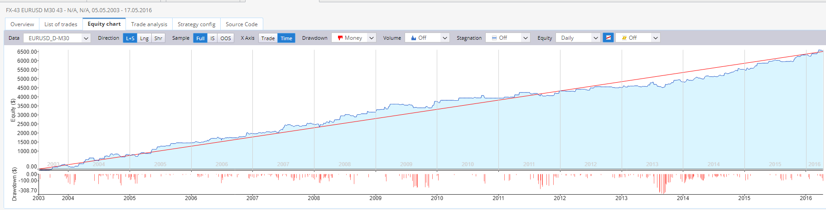
Inhaltsverzeichnis
Analysis 2
Backtests with some dataseries 2
Backtests with Asikury Data 3
Three timeseries 4
OOS2 10.7.2003-10.7.2006 4
Generation 10.7.2006-12.04.2014 5
OOS1 12.04.2014-12.04.2016 6
Robustnesstests 6
TradeManipulation, ASI Data, Resampling 6
Montecarlo Retest 7
Parameter Optimaziation 8
Lower Timeframe M15 9
Higher Timeframe H1 10
Different currencypair GBPUSD M30 11
LongTimeBacktest with AsikuryData 12
Broker Pepperstone 13
Broker Active Trades 13
Broker Tickmill 13
WFA-Matrix 15

Analysis

Backtests with some dataseries
The timeperiod of this backtest is from 10.7.2003 till 12.04.2016
This will the timeperiod for the filter analysis

Backtests with Duka Data

Parameter | Backtest with 3.8.2 (orginal) | Backtest with SQ 4.124 (sel Timeframe) | Backtest with SQ 4.124 (Ticksimul)  Spread 1.0 | SQ 4.124, Spread 2.0, Ticksimul | SQ 4.124, RealTick, Real Spread | SQ 4.124, RealTick, Spread 2.0
#trades | 462 | 461 | 462 | 479 | 452 | 480
Stagnation | 262 | 264 | 264 | 355 | 260 | 355
PF | 2,01 | 2,05 | 2,01 | 1,83 | 2,01 | 1,82
Stability | 0.93 | 0.92 (0.95 old Stabil) | 0,94 | 0,9 | 0,92 | 0,93
RetDD | 20 | 22,57 | 20,35 | 16,92 | 20,05 | 16,6
NetProfit | 6507,8 | 6585 | 6440,7 | 5732 | 6383 | 5668,3
Symetrie | 99,76 | 96,36 | 98,96 | 98,26 | 97,59 | 99,88
WinLoseRat | 1 | 1 | 1 | 0,92 | 1,02 | 0,92

=> Backtester 3.8.2 ↔ 4.124 SelTimeframe ↔ 4.124 Ticksimulation ↔ 4.124 Real Tick is compatibel

Backtests with Asikury Data
from 10.7.2003 till 12.04.2016

Parameter | Backtest with 3.8.2 (orginal) | SQ 4.124, Spread 2.0, Ticksimul, Asikury
#trades | 462 | 443
Stagnation | 262 | 230
PF | 2,01 | 2,24
Stability | 0.93 | 0,92
RetDD | 20 | 30,33
NetProfit | 6507,8 | 7122
Symetrie | 99,76 | 97,15
WinLoseRat | 1 | 1,1

Three timeseries

OOS2 10.7.2003-10.7.2006

Parameter | Ticksimul Duka, Spread 2.0 | Ticksimul Asi, Spread 2.0
#trades | 103 | 98
Stagnation | 97 | 106
PF | 2,39 | 2,79
Stability | 0,89 | 0,88
RetDD | 11,18 | 10,66
NetProfit | 1875 | 2065
Symetrie | 21,66 | 43
WinLoseRat | 1,45 | 1,65
AvAbsTrade | 44 | 44
Anu%Return | 2,76 | 5,21
AverProfitMonth | 52 | 57
Exposure | 0,18 | 0,18%

Generation 10.7.2006-12.04.2014

Parameter | Ticksimul Duka, Spread 2.0 | Ticksimul Asi, Spread 2.0
#trades | 286 | 259
Stagnation | 335 | 230
PF | 1,6 | 2,02
Stability | 0,88 | 0,91
RetDD | 7,69 | 15,49
NetProfit | 2625 | 3632
Symetrie | 80,53 | 92
WinLoseRat | 0,8 | 0,98
AvAbsTrade | 39,5 | 40
Anu%Return | 1,45 | 1,63
AverProfitMonth | 32 | 44,29
Exposure | 0,11 | 0,14%

OOS1 12.04.2014-12.04.2016

Parameter | Ticksimul Duka, Spread 2.0 | Ticksimul Asi, Spread 2.0
#trades | 89 | 84
Stagnation | 106 | 93
PF | 2,12 | 2,26
Stability | 0,91 | 0,92
RetDD | 8,95 | 10,02
NetProfit | 1250 | 1324
Symetrie | 19 | 33,42
WinLoseRat | 0,89 | 0,95
AvAbsTrade | 38,81 | 40,33
Anu%Return | 5,93 | 5,93
AverProfitMonth | 54,43 | 57,57
Exposure | 0,27 | 0,27%

Robustnesstests

TradeManipulation, ASI Data, Resampling

2006.7.10-2014.04.12
Hinweis: Verwende für diesen Robustnesstest Asi data. Der RT mit Dukadata failed jedesmal

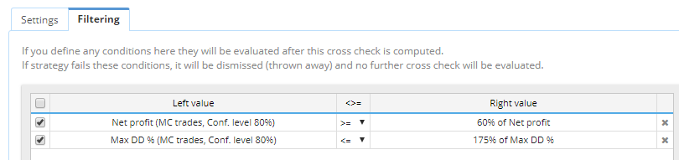
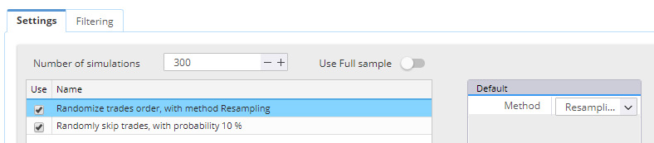
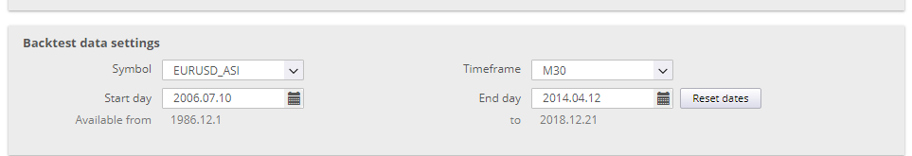

Montecarlo Retest
With Asi und Duka Data

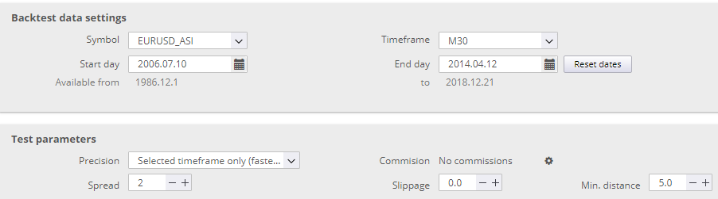

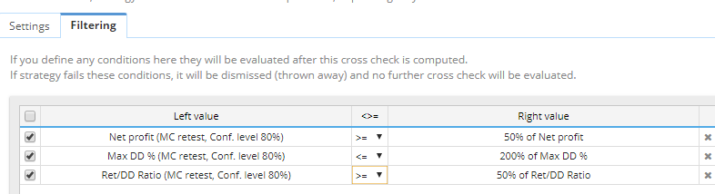
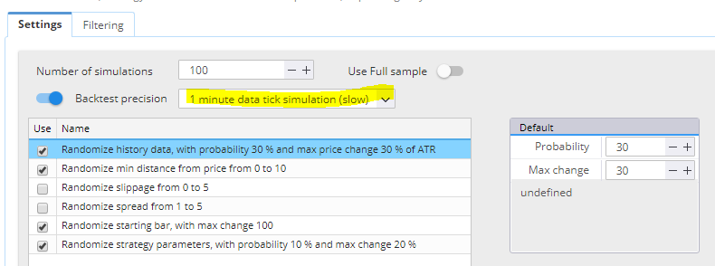
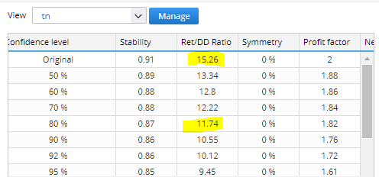
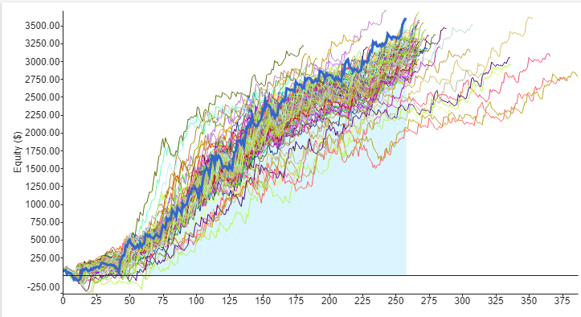

Parameter Optimaziation
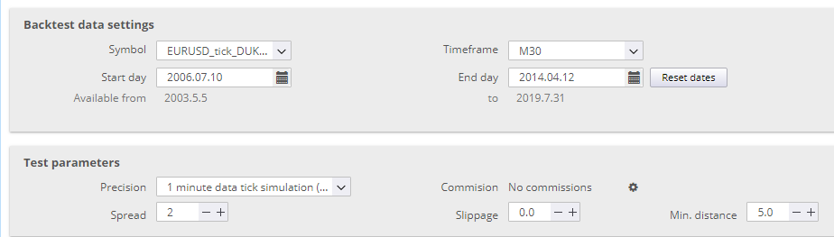
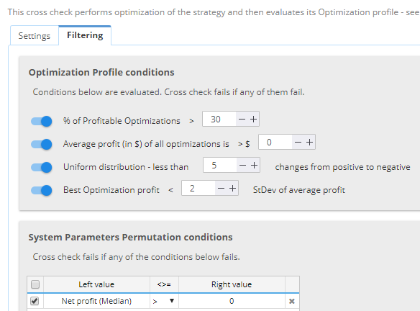

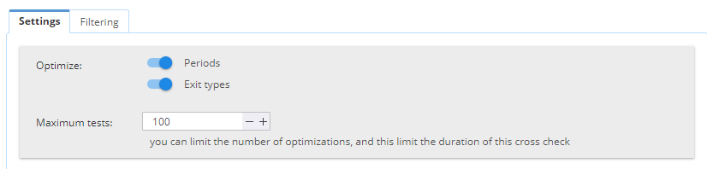
Lower Timeframe M15
EURUSD M15, Spread 1.0
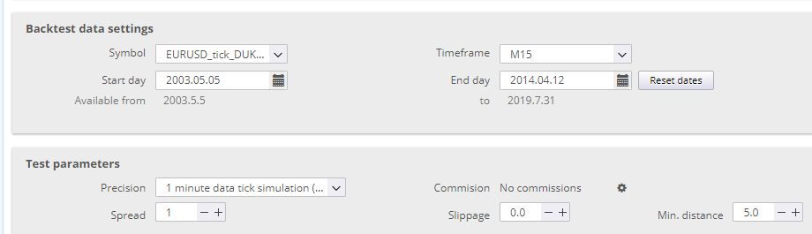
Parameter | Value Dukadata | Value Asi-Data
Stability | 0,87 | 0,86
PF | 1,64 | 2,01
RetDD | 15,31 | 33,03
NetProf | 6644 | 8663
Symetrie | 0 | 73
AvgAbsTrade | 0 | 32
Anual%Return | 2,29 | 4,01
Average Profit | 0 | 57,68
Exposure | 0 | 0
#Trades | 877 | 797
Stagnation | 476 | 223

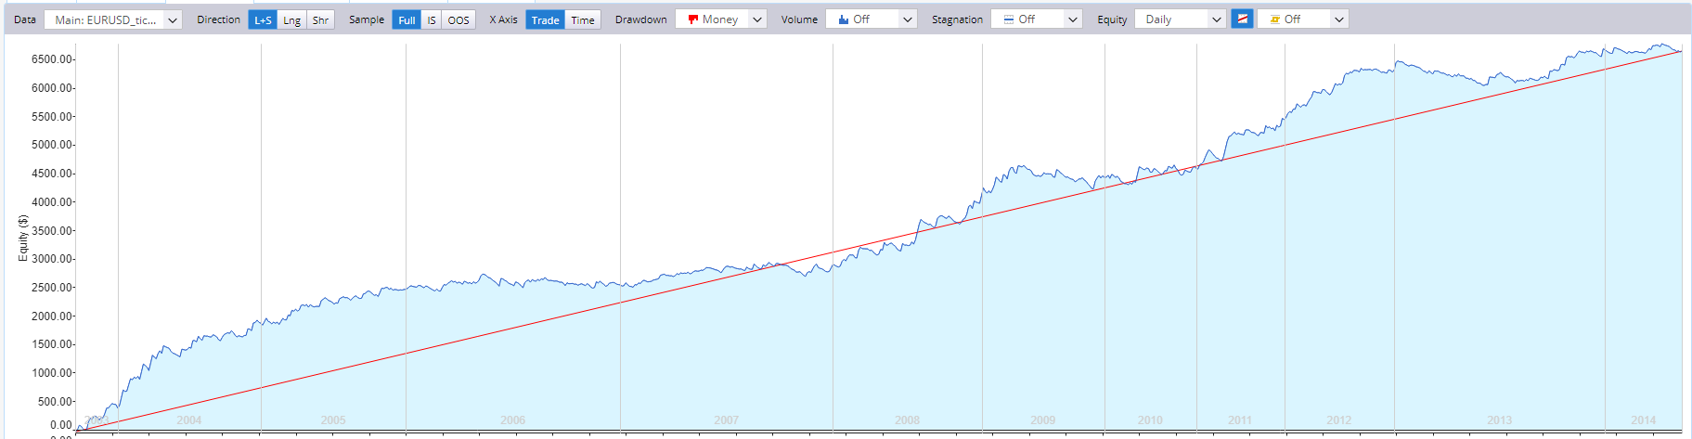

Higher Timeframe H1
EURUSD H1, Spread 2.0
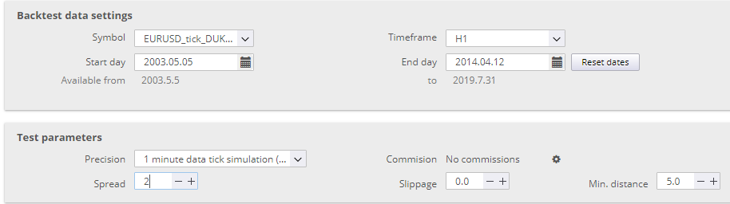
Parameter | Value Dukadata | Value Asi-Data
Stability | 0,7 | 0,8
PF | 2,06 | 2,21
RetDD | 8,19 | 9,68
NetProf | 2602,6 | 2837
Symetrie | 73 | 66
AvgAbsTrade | 54 | 57
Anual%Return | 0,62 | 0,73
Average Profit | 31 | 35
Exposure | 0,7 | 0,7
#Trades | 137 | 131
Stagnation | 1252 | 1021
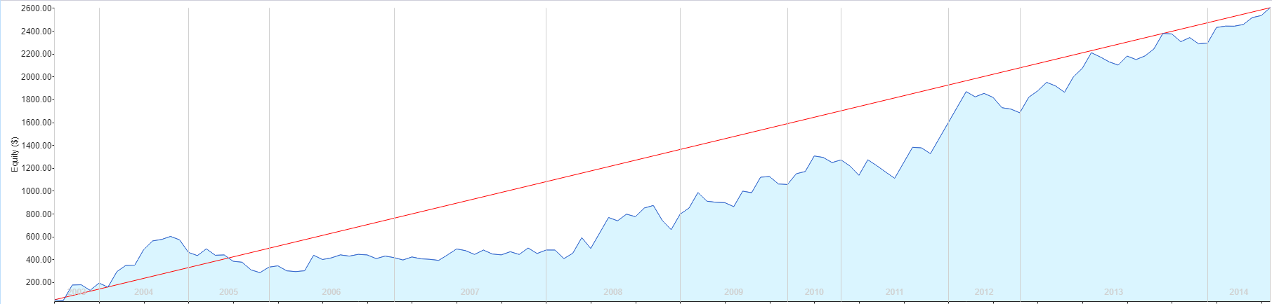

Different currencypair GBPUSD M30
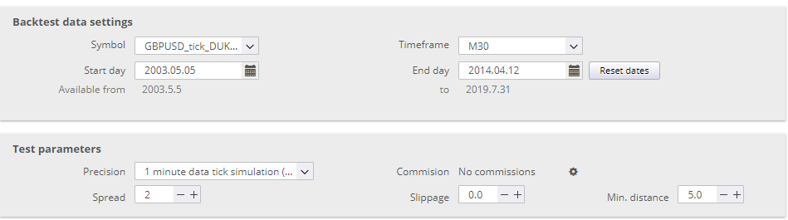

Parameter | Value Dukadata | Value Asi-Data
Stability | 0,72 | 0,76
PF | 1,3 | 1,44
RetDD | 3,59 | 12,54
NetProf | 4096 | 5290
Symetrie | 19,76 | 49,49
AvgAbsTrade | 44,9 | 44,97
Anual%Return | 0,58 | 1,35
Average Profit | 32 | 41,98
Exposure | 0,55 | 0,38
#Trades | 689 | 647
Stagnation | 1629 | 876

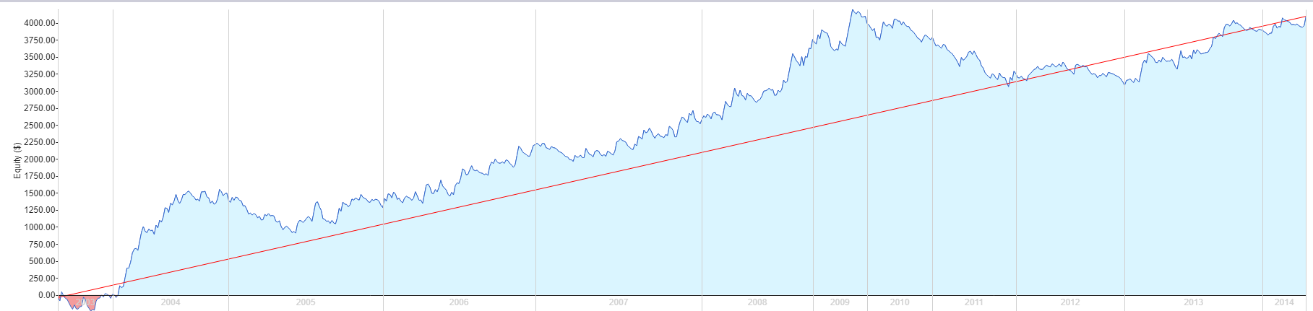

LongTimeBacktest with AsikuryData
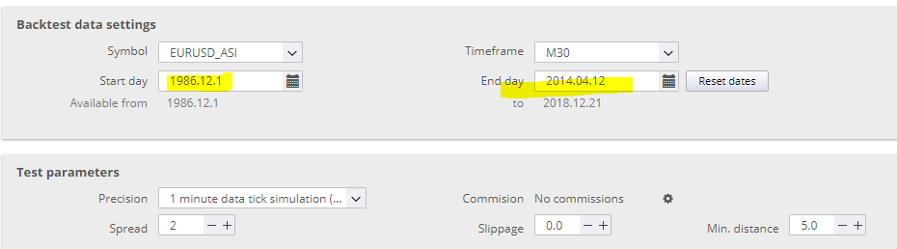
Parameter | Value Asi-Data
Stability | 0,9
PF | 2,17
RetDD | 42,17
NetProf | 10222
Symetrie | 95
AvgAbsTrade | 41
Anual%Return | 0,57
Average Profit | 38,28
Exposure | 0,1
#Trades | 664
Stagnation | 1211

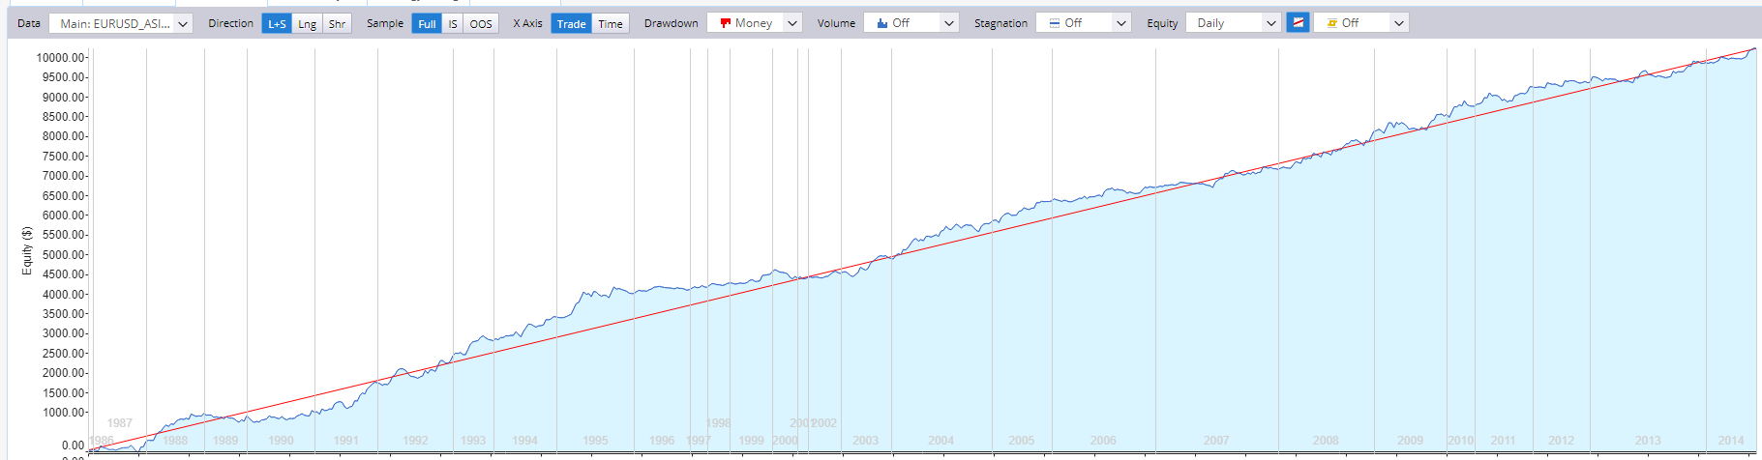
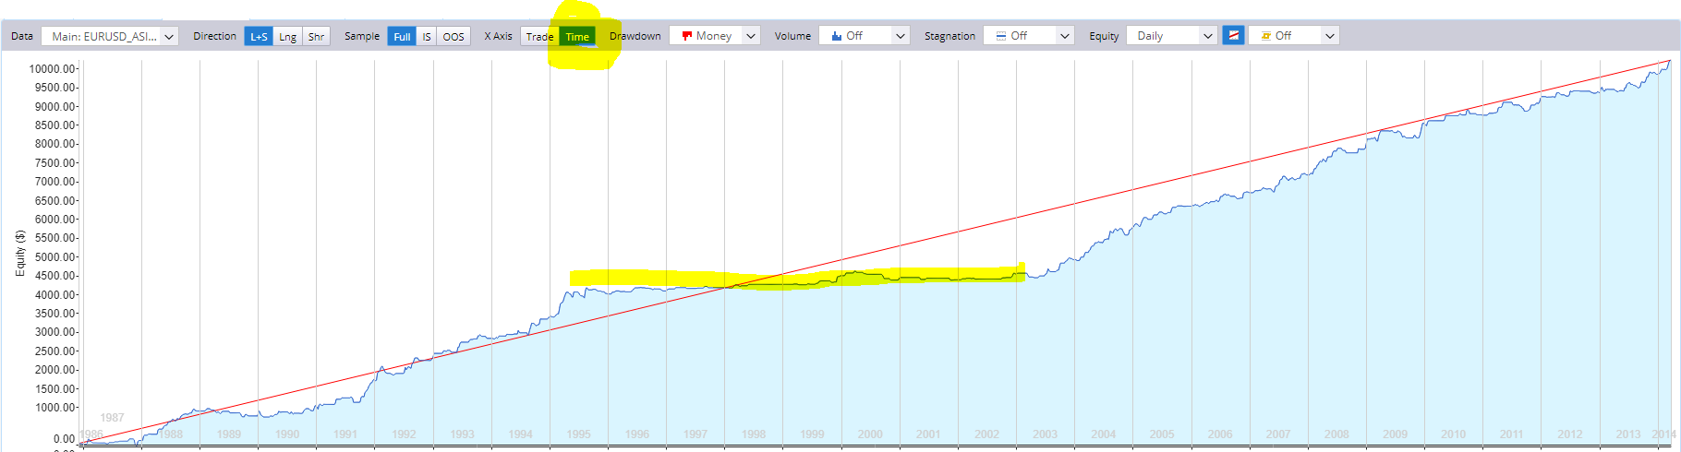

Broker Pepperstone
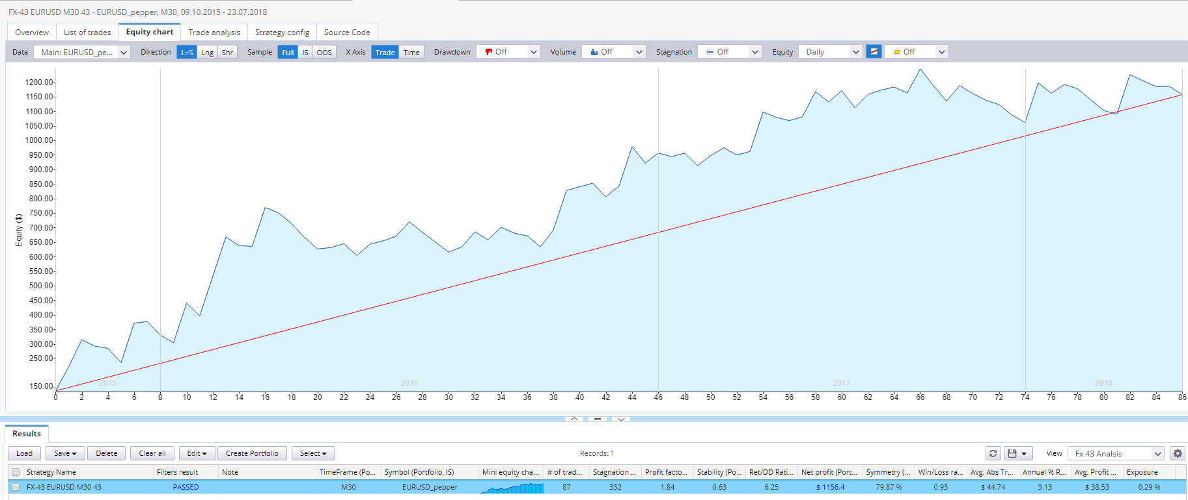

Broker Active Trades

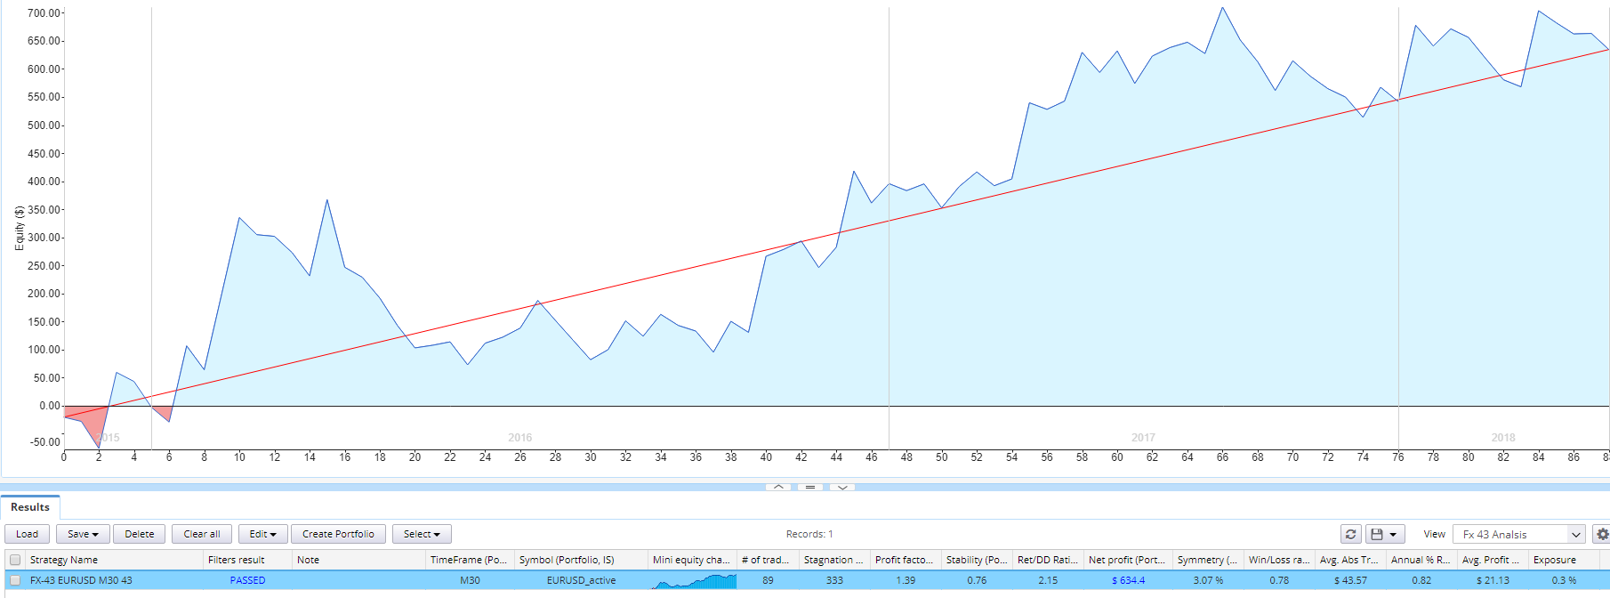
Broker Tickmill
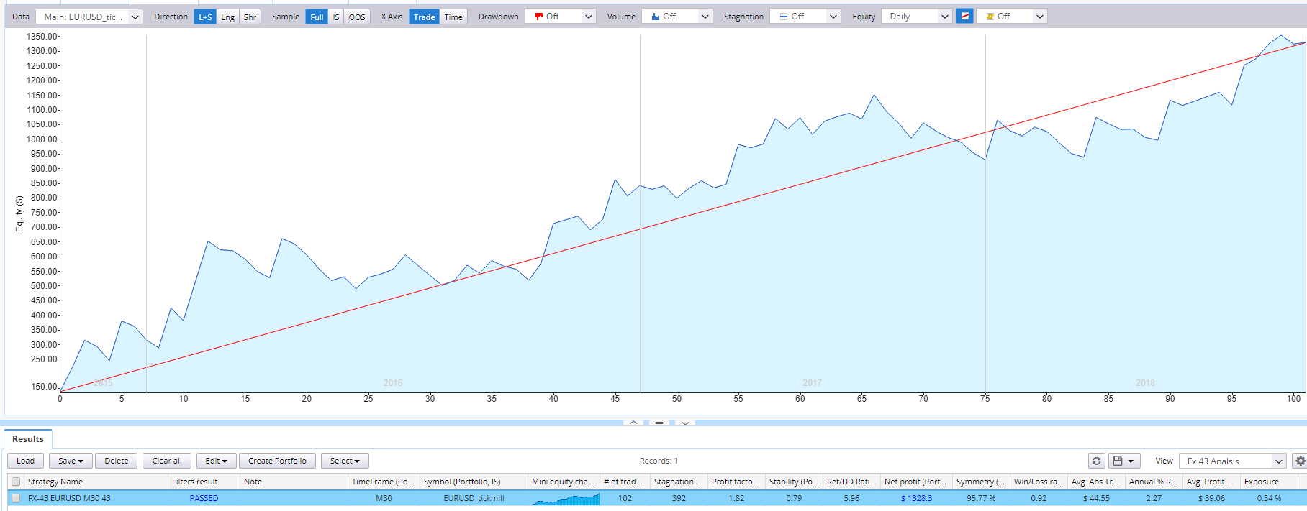

Broker Jfd
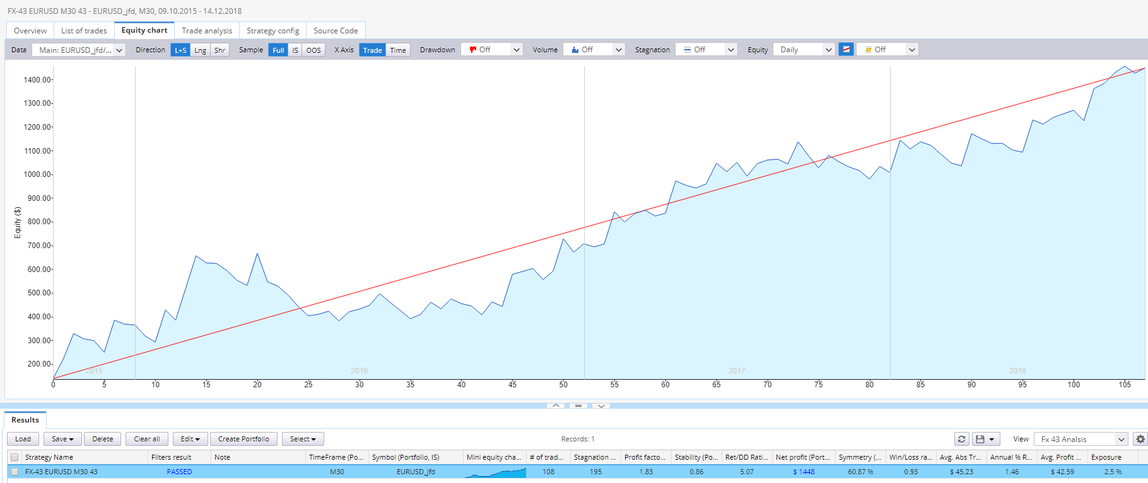

WFA-Matrix
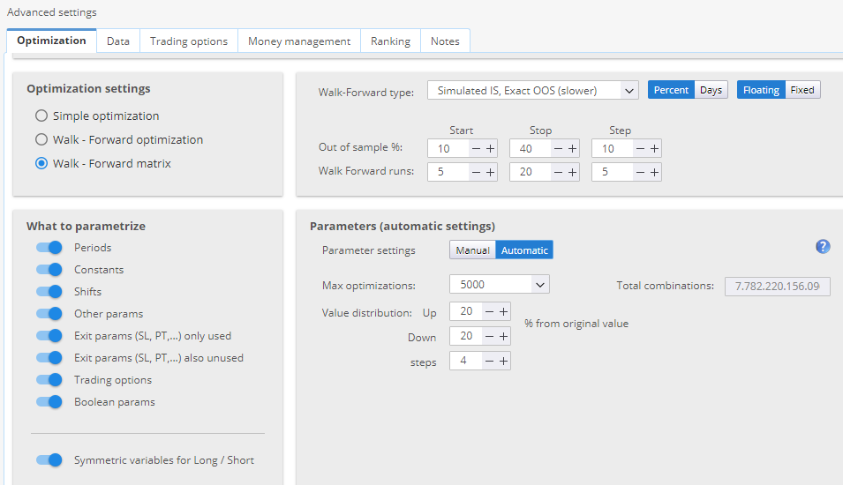
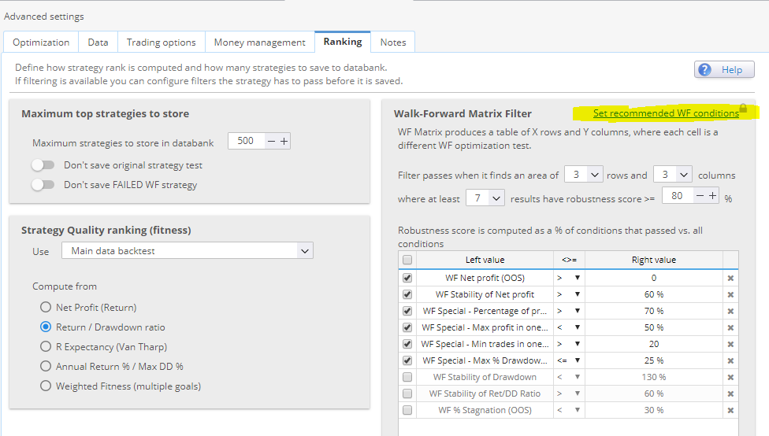
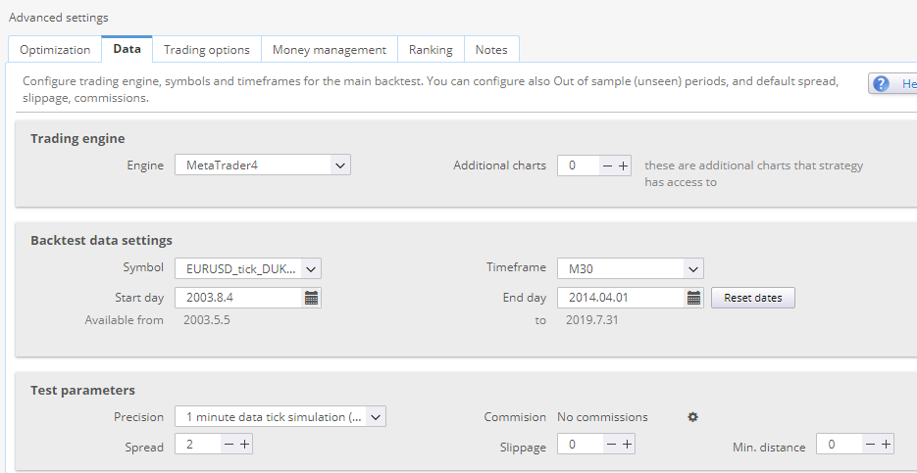

Real Tick- real Spread (slowest) Spread 1.0, Slippage0
Spread 1.0, Slippage 0
Real Tick- real Spread (slowest) Spread 1.0, Slippage0

